1. Sub-flows pick up the execution context (exception handler, transaction, properties) from where?

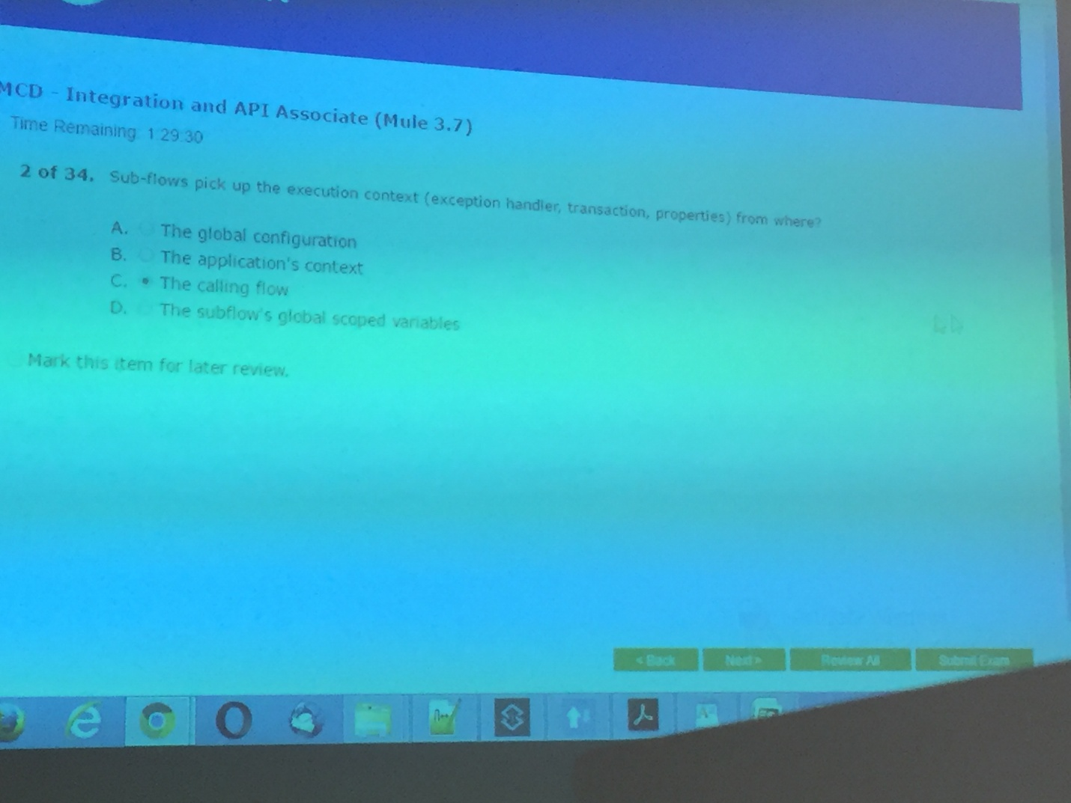

1. For the RAML file below, how many flows (excluding the APIKit Router flow) would be generated by APIKit by default to support the resource method pairings?

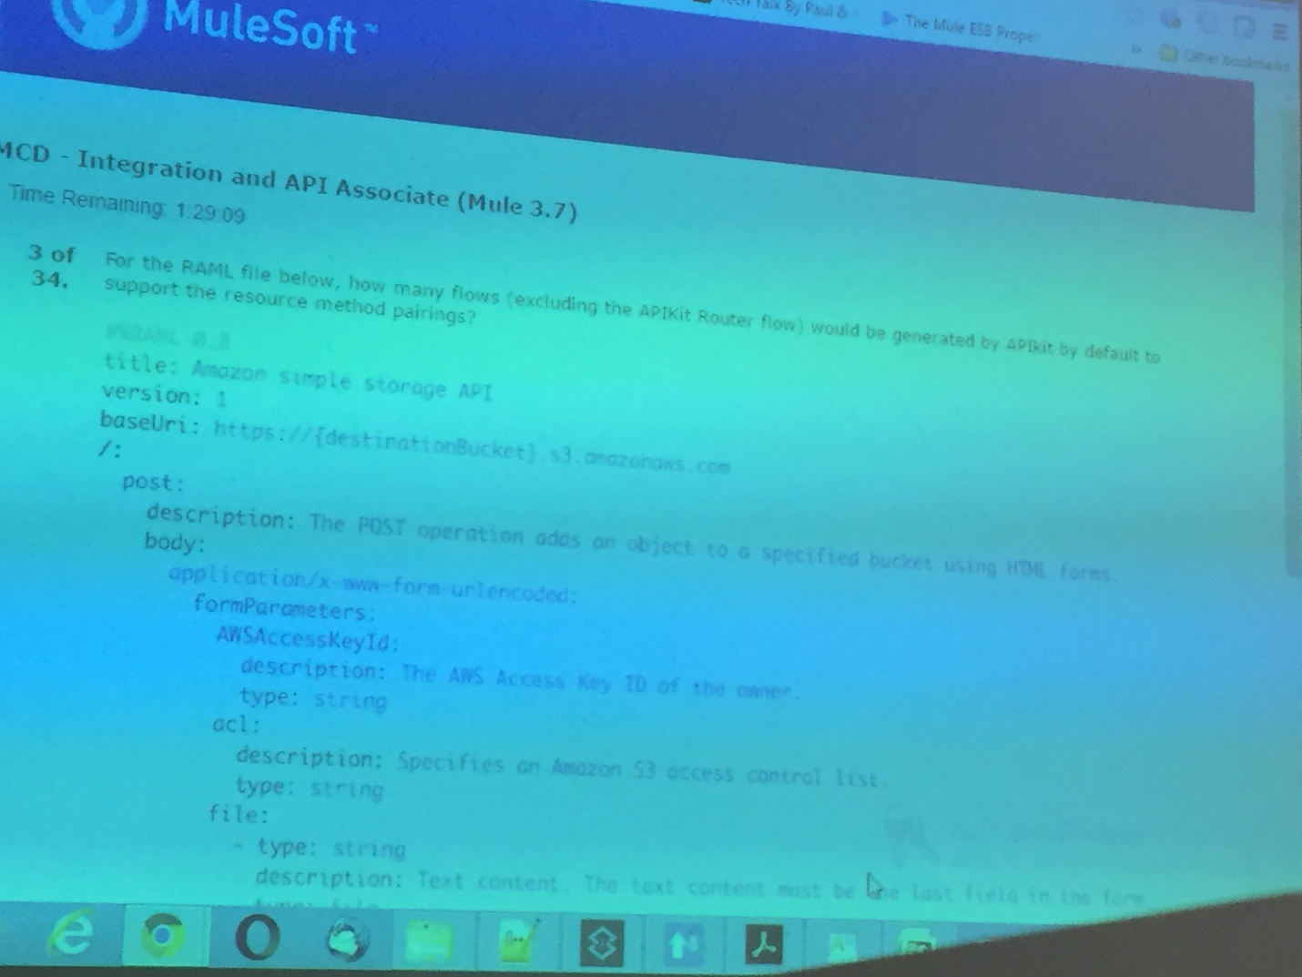

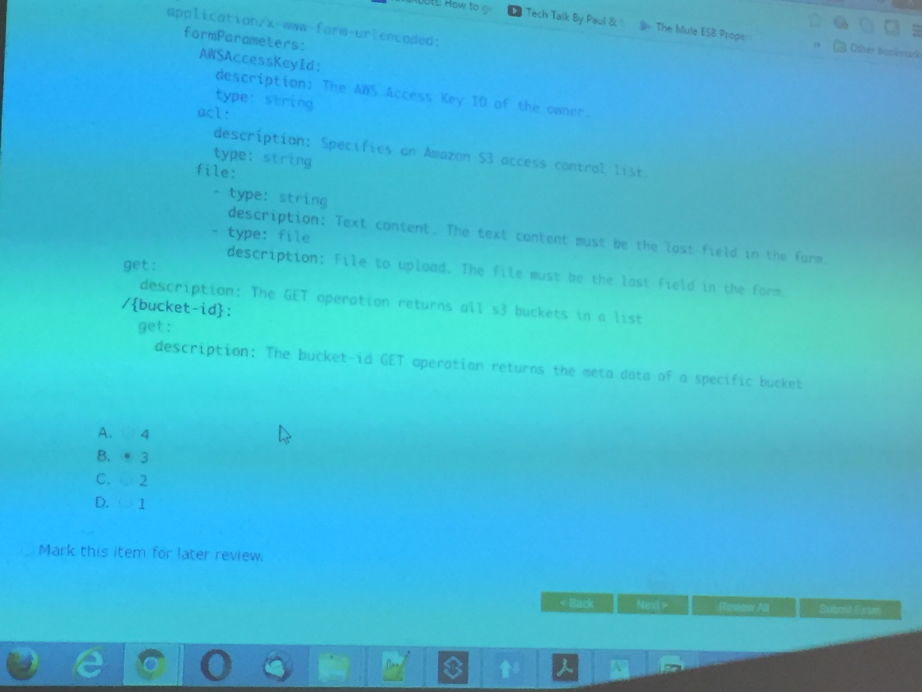

1. Which of the following transports only supports the one-way exchange-pattern?

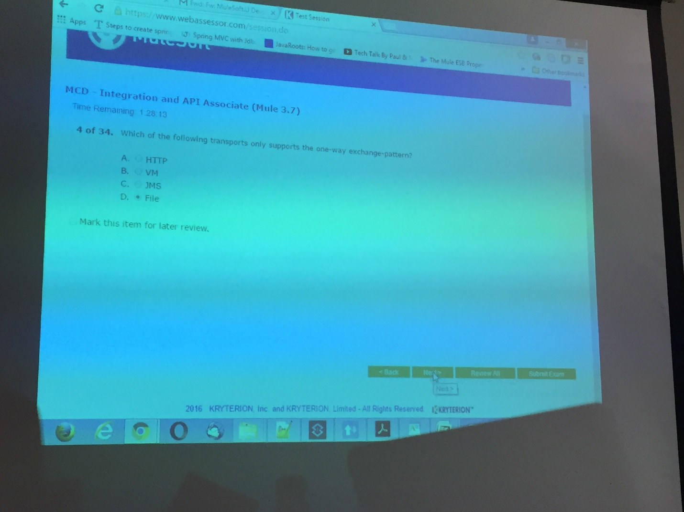

1. What is the expected behavior of an inbound FTP endpoint placed within the source of flow?

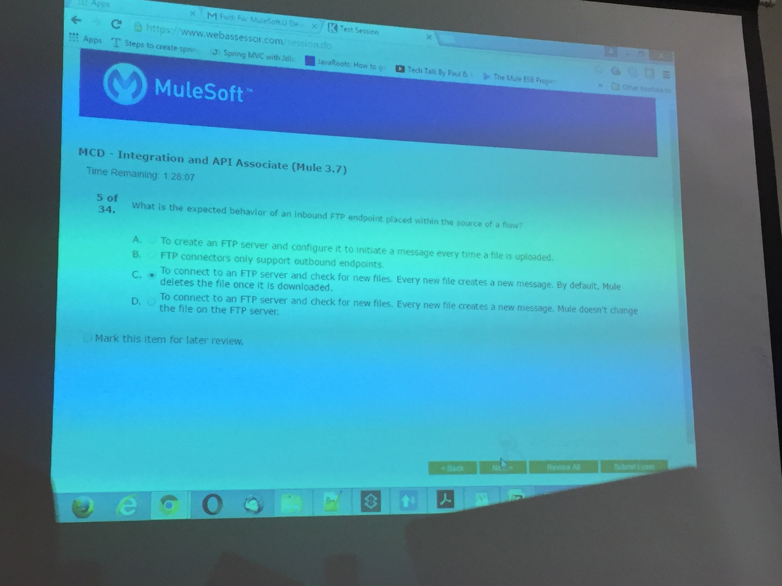

1. What information is available to the batch job at point A?

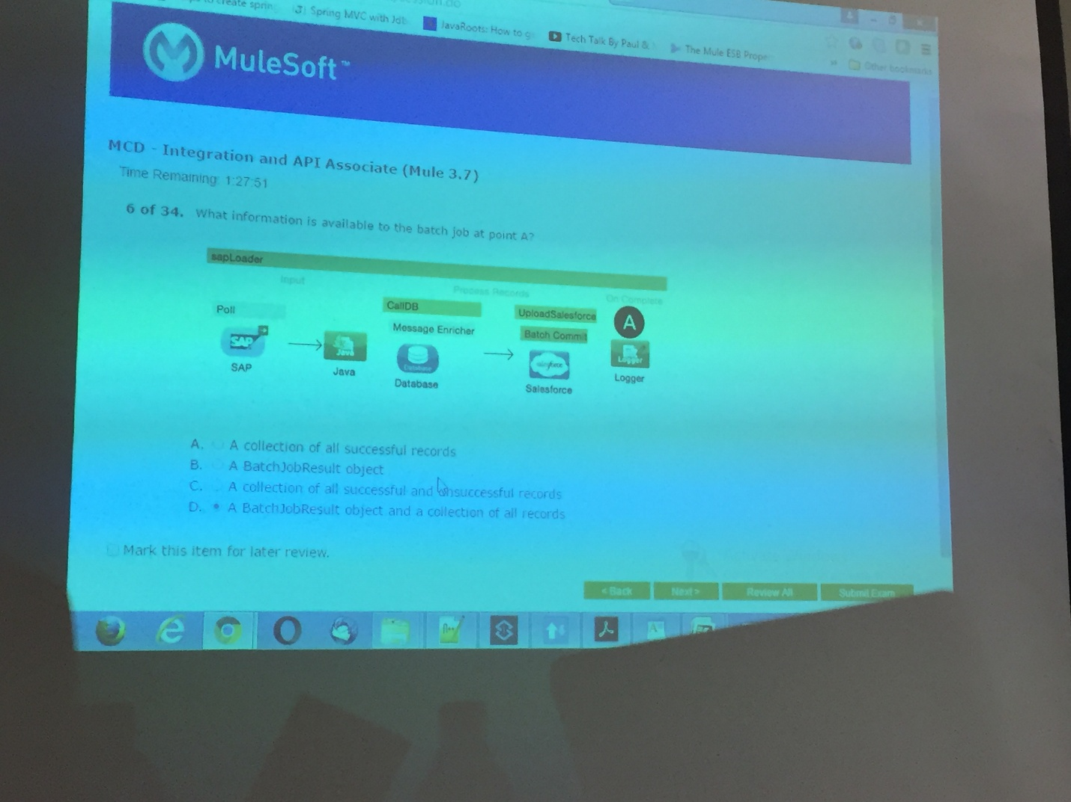

1. What does the payload of a mule message always contain?

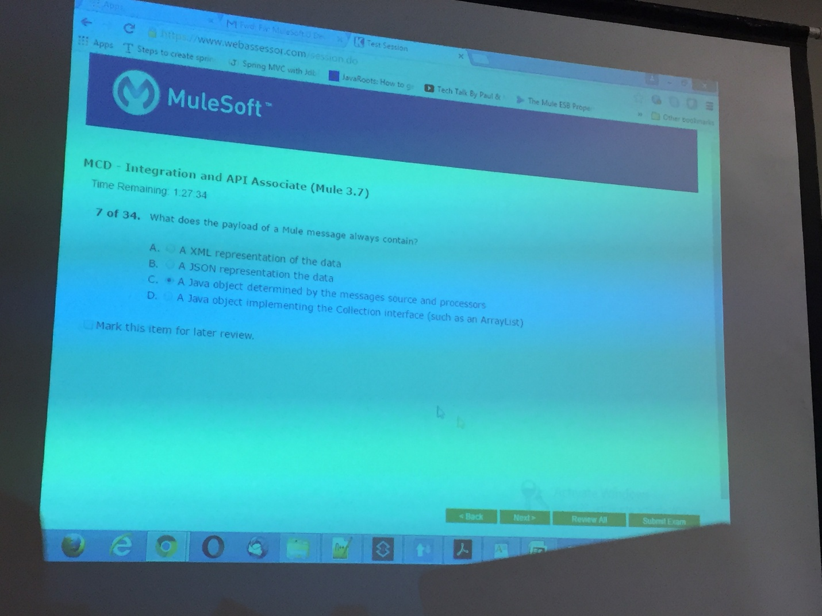

1. In the image below, s variables are session variables and f variables are flow variables, what variables are available to the message at point A?

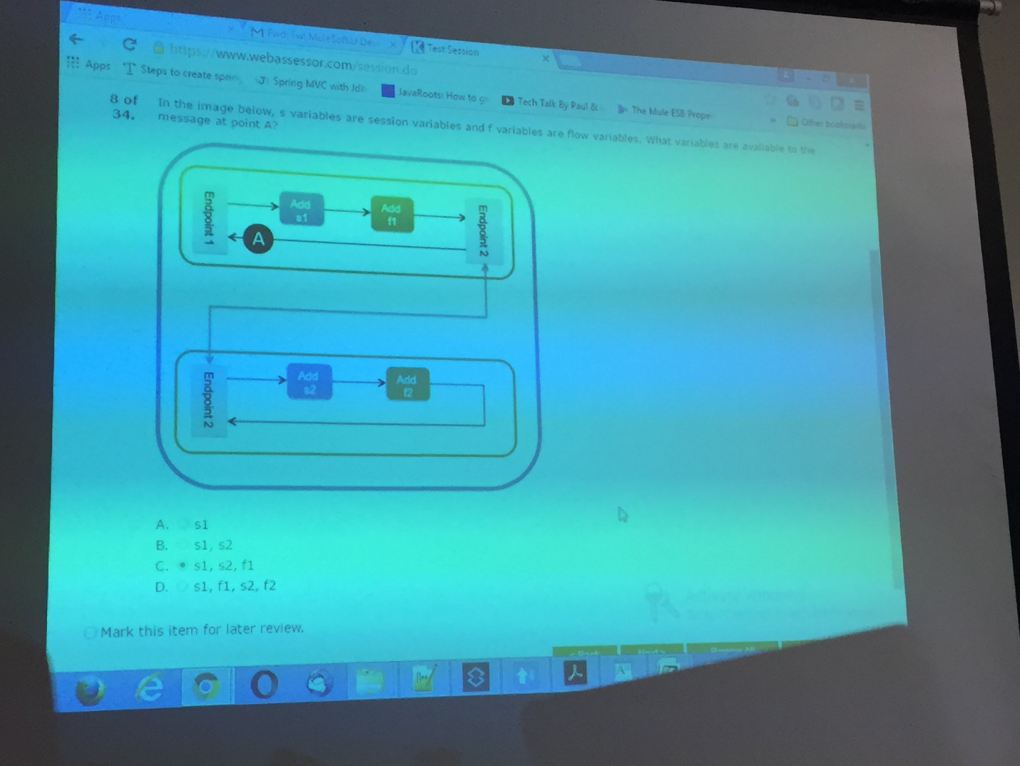

1. A mule application is configured with the following element in the global scope:

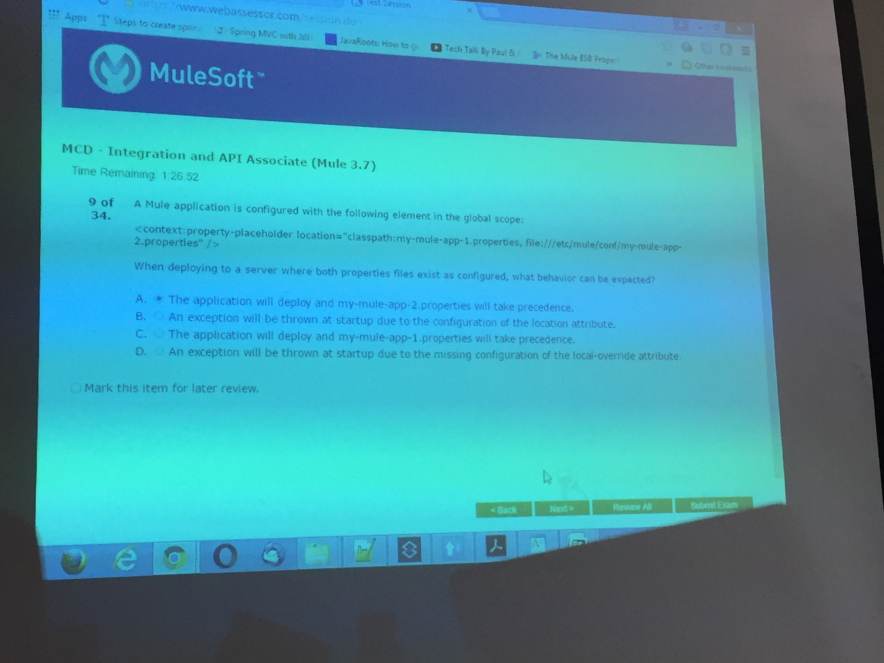

1. What does the APIKit router not do?

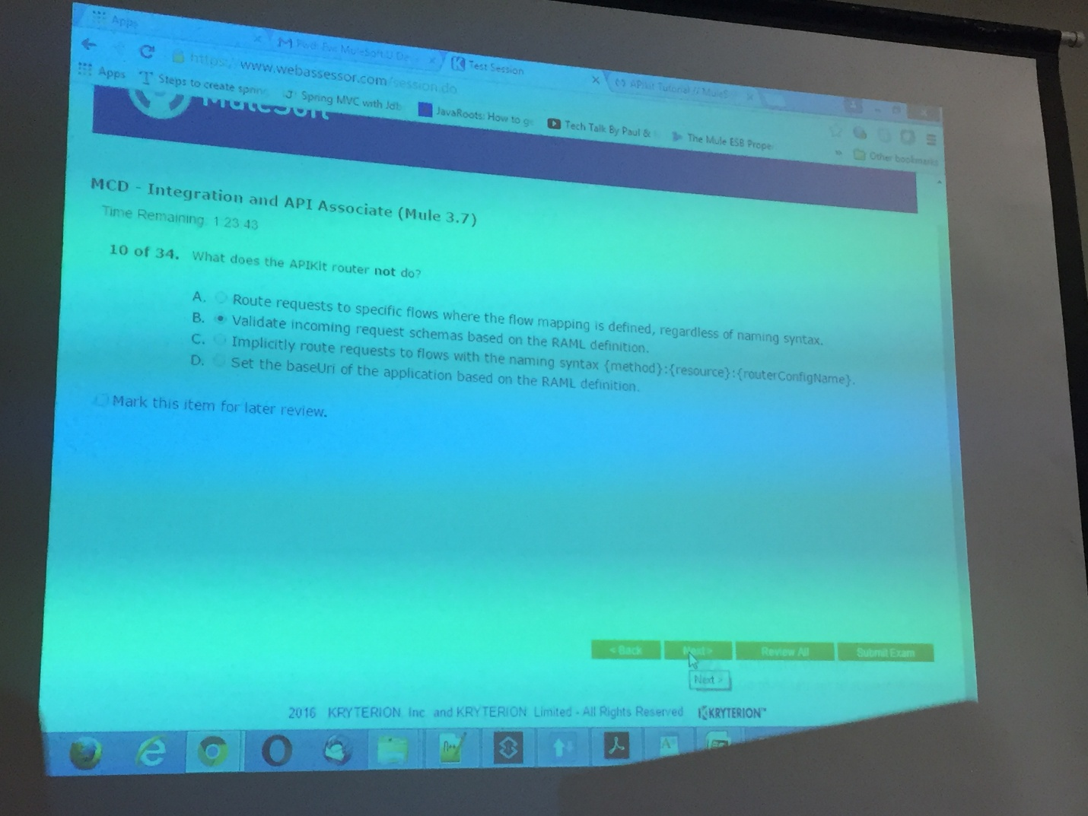

1. When using the mule debugger to examine the mule message at point A in the flow below, what is true about the current state of the message?

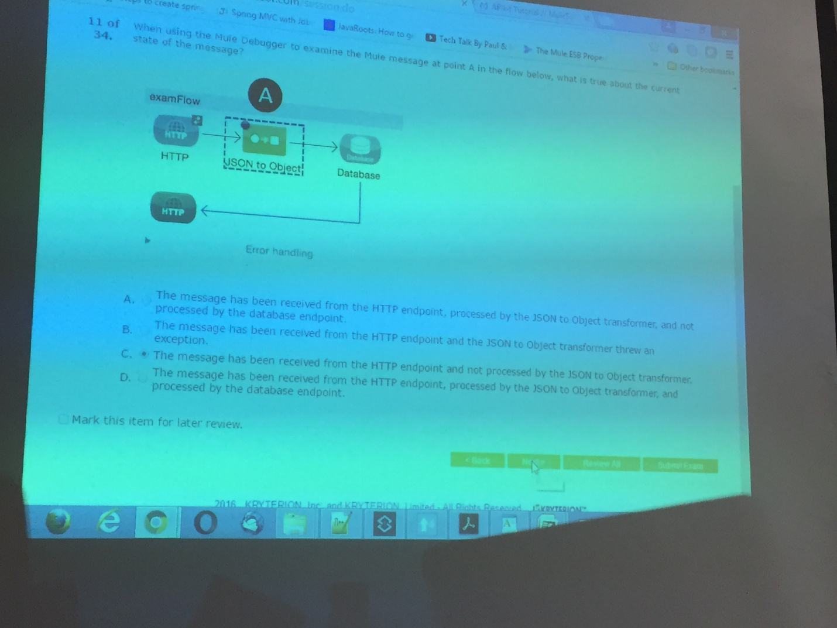

1. Payload metadata is automatically created for which “two” types of connector endpoints? 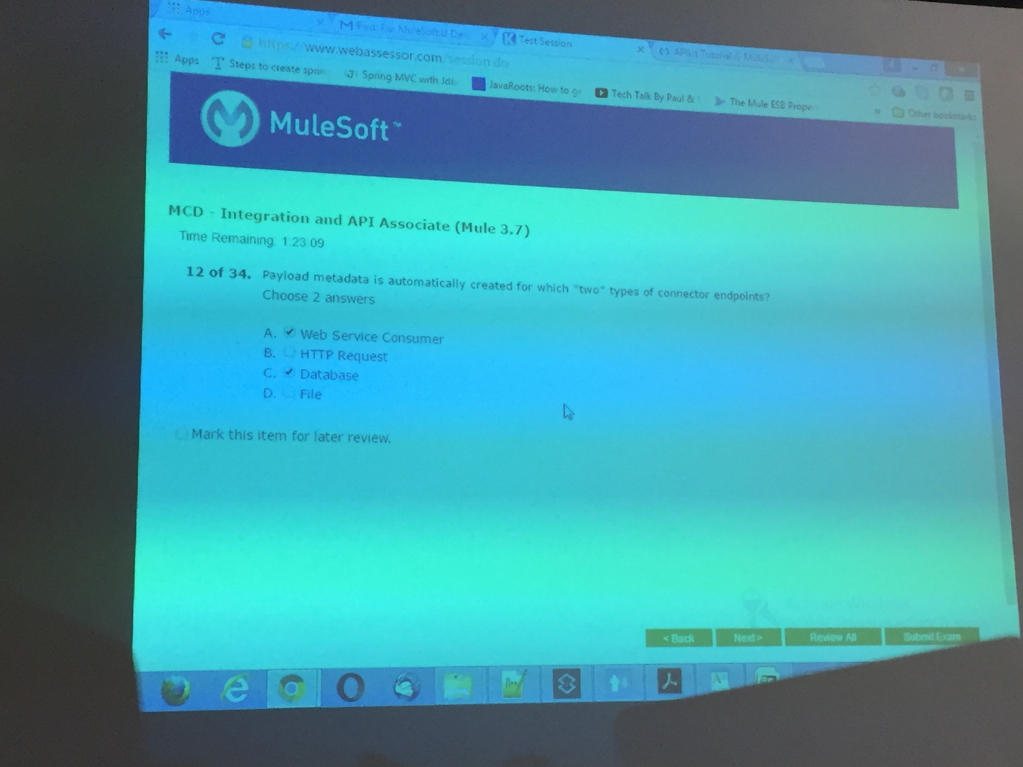
2. You need to send a single mule message off to 6 resources that are not dependent on one another. Each route should be processed concurrently and the result from each route must be aggregated and moved on for further processing. Which router best suits this use case? 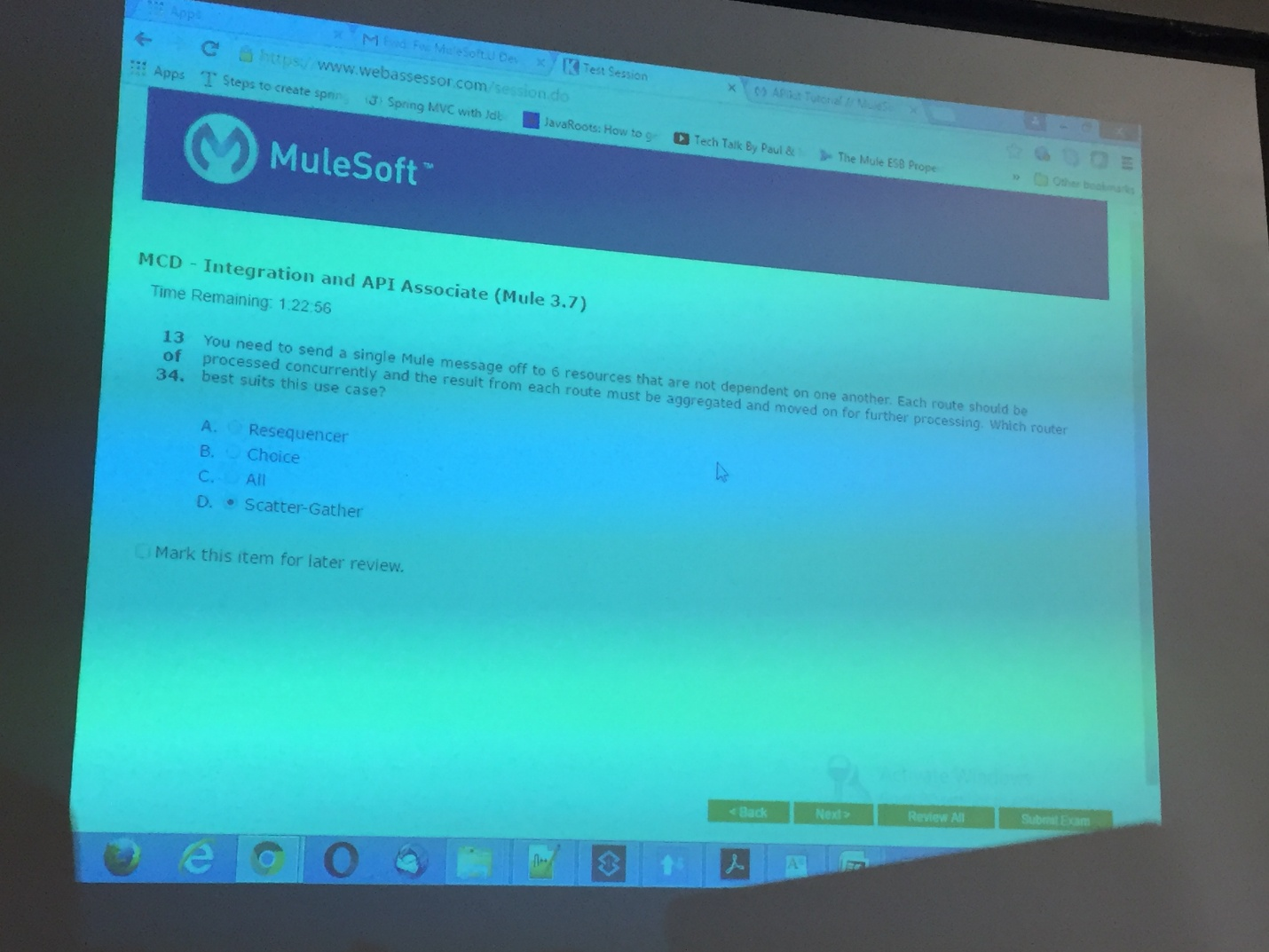
3. Which part of the mule message is considered immutable? 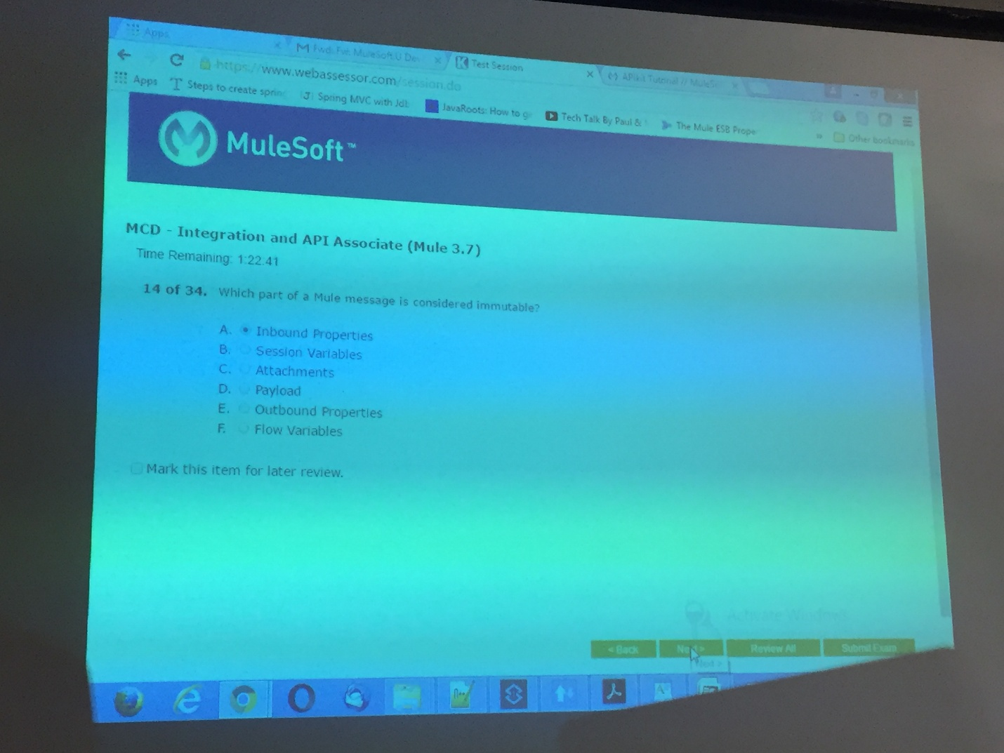
4. Which case best warrants the use of a subflow? 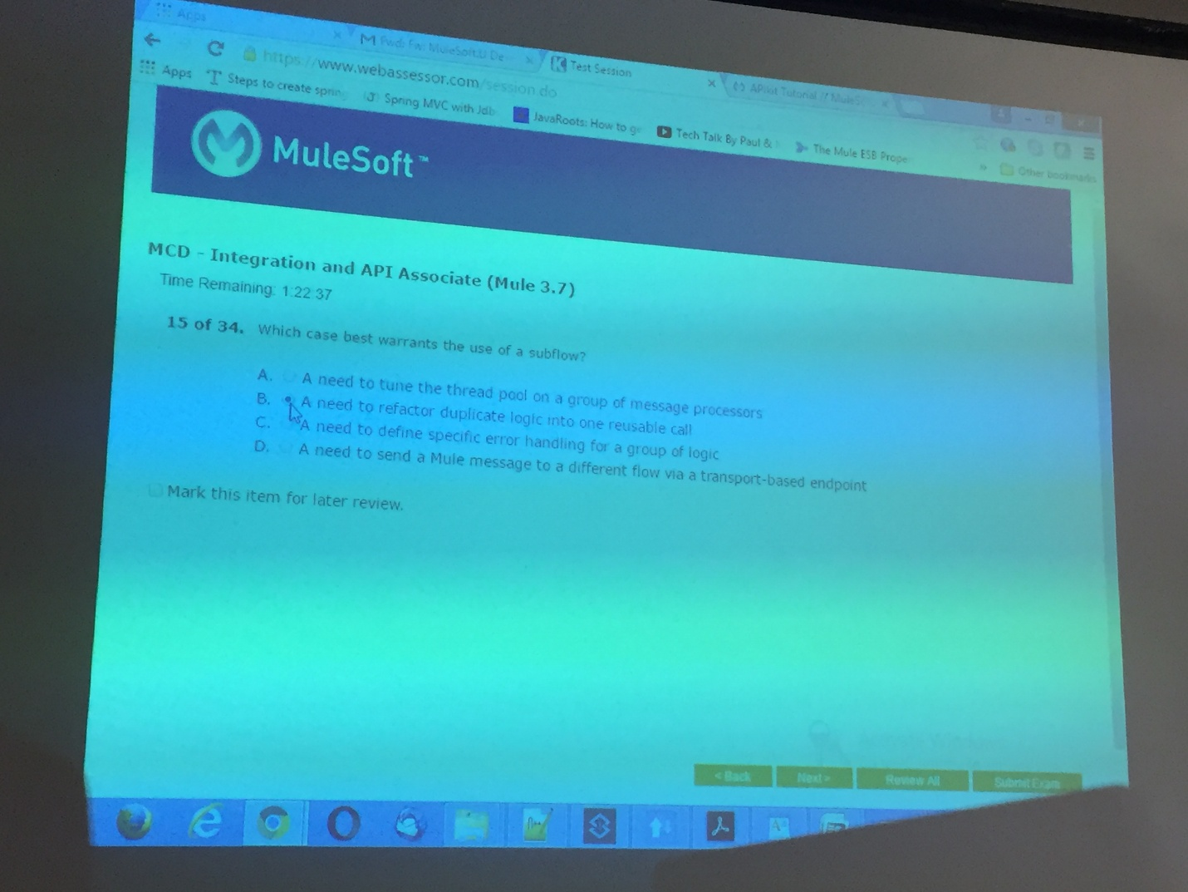
5. In the flow below, how can you ensure the Content-Type inbound-property that exists at point A is propagated into an HTTP header after crossing point B? 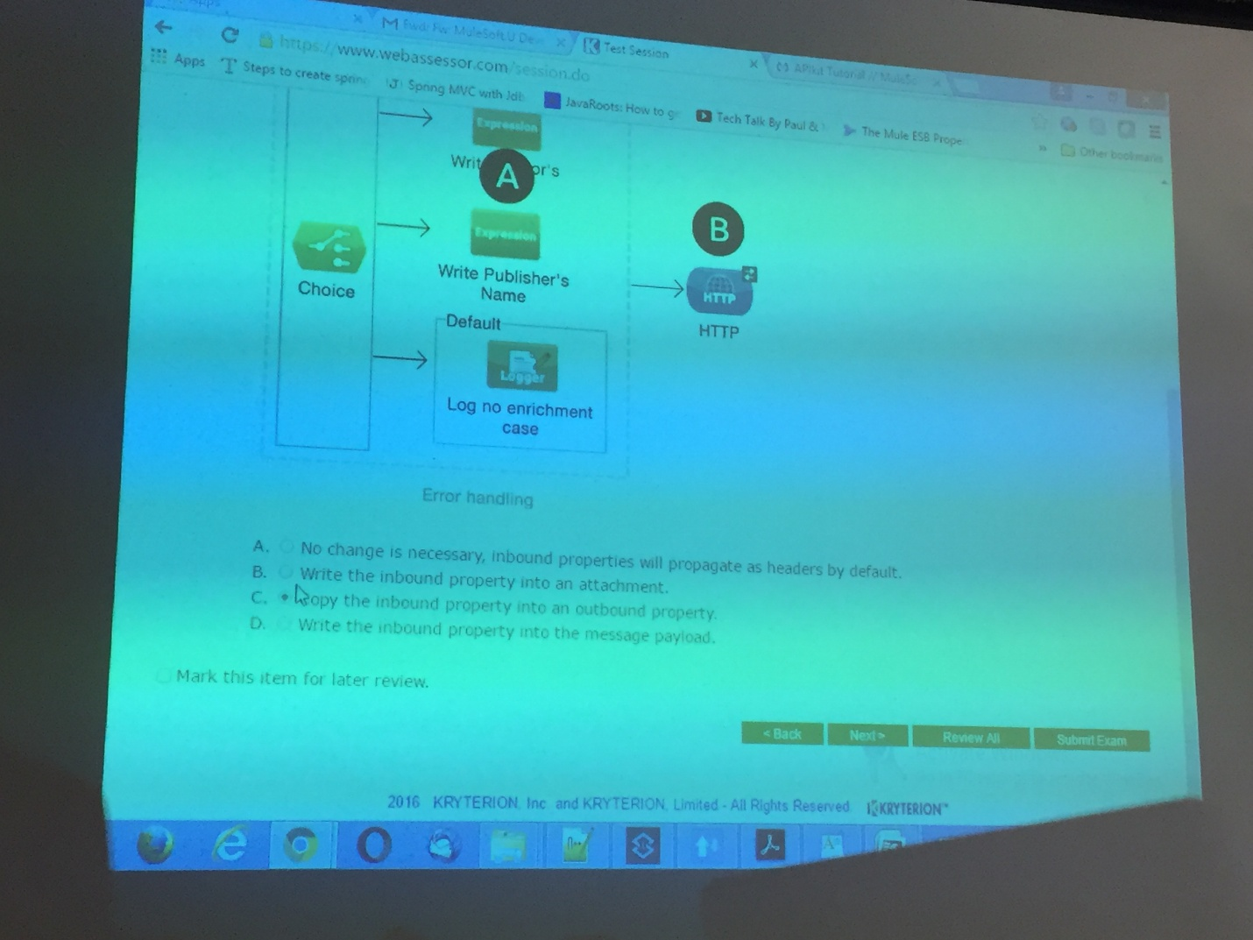
6. The data in image A is POSTed to the resource in image B. For the flow in image C, which logger will be executed? 